Class Test 02
PL/SQL
Part 01:
- Write a query that displays Hello ADBMS Section A using the concept of literal.
- Write a query that can add two numbers using the concept of inner block and outer block.
- Write a query that can multiply three numbers using the concept of literal.
- Write a query that stores Hello World in a variable and displays it in block letters.
- Write a query that can subtract a smaller number from a larger number and display the result using the concept of variable.
- There are four numbers given i.e. 12,14,16,18. Find out the average.
- Write a query that displays the value of pi using the concept of constant.

Part 02:
To solve the following use the scott schema
- Write a query that can display the name of the department which has department number 10.
- Write a query that can display the name of the department in lower case which has department number 20.
- Write a query that displays the incremented salary (sal+250) of employee Smith.
- Write a query that displays the hiredate of employee KING.
- Write a query that displays the sum of salary of all the employees.
- Write a query that displays the salary and commission of employee Allen.
- Write a query that displays only those employees who have TT (double T) in their name.

**After solving the above questions using Oracle 10g, write the PL/SQLs in a MS Word document (Write down the answer and give screenshot of the result of the query. The name of the document MUST be your ID and the PL/SQLs MUST be numbered accordingly) and upload it in the provided link in your VUES account

Part: 01
Part: 01
- Write a query that displays Hello ADBMS Section A using the concept of literal.

BEGIN
DBMS_OUTPUT.PUT_LINE('Hello ADBMS Section A');
END;

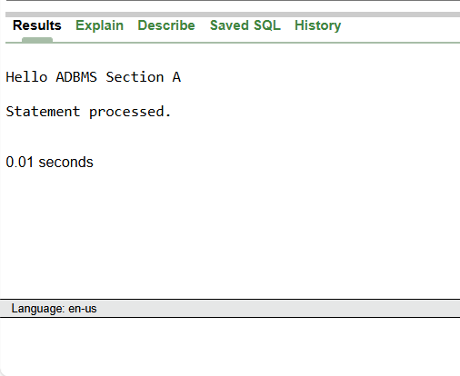
- Write a query that can add two numbers using the concept of inner block and outer block.

DECLARE
n1 NUMBER := 100;
n2 NUMBER := 200;
BEGIN
DECLARE
result NUMBER;
BEGIN
result := n1 + n2;
DBMS_OUTPUT.PUT_LINE('Sum: ' || result);
END;
END;

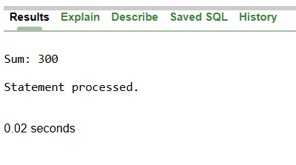
- Write a query that can multiply three numbers using the concept of literal.

BEGIN
DBMS_OUTPUT.PUT_LINE(5 * 5 * 5);
END;

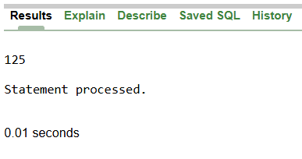

- Write a query that stores Hello World in a variable and displays it in block letters.

DECLARE
mesg VARCHAR2(20) := 'Hello World';
BEGIN
DBMS_OUTPUT.PUT_LINE(UPPER(mesg));
END;

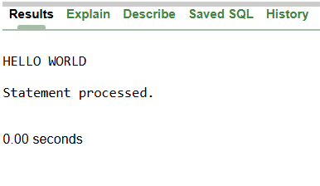

- Write a query that can subtract a smaller number from a larger number and display the result using the concept of variable.

DECLARE
n1 NUMBER := 100;
n2 NUMBER := 200;
result NUMBER;
BEGIN
result := GREATEST(n1, n2) - LEAST(n1, n2);
DBMS_OUTPUT.PUT_LINE('Result: ' || result);
END;

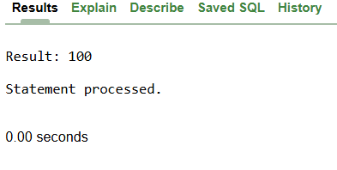

- There are four numbers given i.e. 12,14,16,18. Find out the average.

DECLARE
average NUMBER;
BEGIN
average := (12 + 14 + 16 + 18) / 4;
DBMS_OUTPUT.PUT_LINE('Average: ' || average);
END;

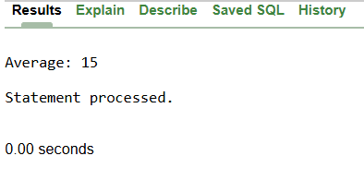
- Write a query that displays the value of pi using the concept of constant.

DECLARE
PI CONSTANT NUMBER := 3.1415926536;
BEGIN
DBMS_OUTPUT.PUT_LINE('Value of PI: ' || PI);
END;

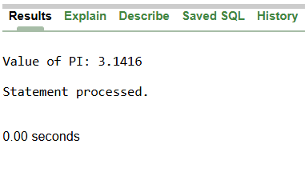

Part: 02
Part: 02
- Write a query that can display the name of the department which has department number 10.

DECLARE
deptName VARCHAR2(50);
BEGIN
SELECT dname INTO deptName
FROM dept
WHERE deptno = 10;
DBMS_OUTPUT.PUT_LINE('Department Name: ' || deptName);
END;

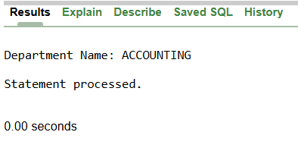

- Write a query that can display the name of the department in lower case which has department number 20.

DECLARE
deptName VARCHAR2(50);
BEGIN
SELECT LOWER(dname) INTO deptName
FROM dept
WHERE deptno = 20;
DBMS_OUTPUT.PUT_LINE('Lowercase Department Name: ' || deptName);
END;

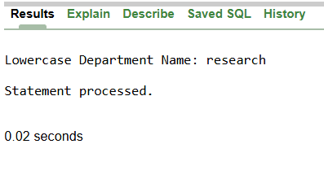

- Write a query that displays the incremented salary (sal+250) of employee Smith.

DECLARE
newSal NUMBER;
BEGIN
SELECT sal + 250 INTO newSal
FROM emp
WHERE ename = 'SMITH';
DBMS_OUTPUT.PUT_LINE('Smith''s New Salary: ' || newSal);
END;

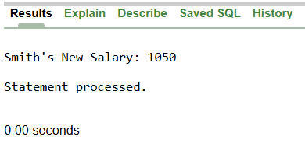

- Write a query that displays the hiredate of employee KING.

DECLARE
empHD DATE;
BEGIN
SELECT hiredate INTO empHD
FROM emp
WHERE ename = 'KING';
DBMS_OUTPUT.PUT_LINE('King''s Hire Date: ' || empHD);
END;

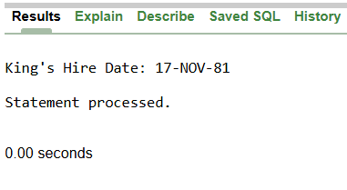

- Write a query that displays the sum of salary of all the employees.

DECLARE
totalSal NUMBER;
BEGIN
SELECT SUM(sal) INTO totalSal
FROM emp;
DBMS_OUTPUT.PUT_LINE('Total Salary: ' || totalSal);
END;

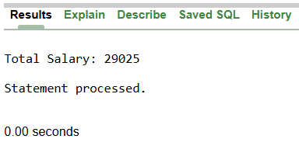

- Write a query that displays the salary and commission of employee Allen.

DECLARE
allenSal NUMBER;
allenComm NUMBER;
BEGIN
SELECT sal, comm INTO allenSal, allenComm
FROM emp
WHERE ename = 'ALLEN';
DBMS_OUTPUT.PUT_LINE('Allen - Salary: ' || allenSal || ', Commission: ' || allenComm);
END;

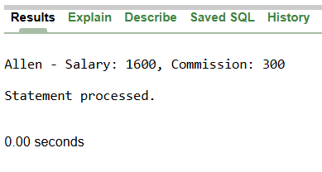
- Write a query that displays only those employees who have TT (double T) in their name.

DECLARE
empTT VARCHAR2(50);
BEGIN
SELECT ename INTO empTT
FROM emp
WHERE ename LIKE '%TT%';
DBMS_OUTPUT.PUT_LINE('Employees with "TT": ' || empTT);
END;



